LAB REPORT实验报告
Lab Title | Pointers |  |  |  | Lab No. | 4
Stud. Name | Jiang Yunxiang | Major | CST |  | Class
Student ID | 2022102330 |  | Date | 3/17
Lab description/objectives:
Using pointers
Source code:
（Paste the source code here）
#include<stdio.h>

void date(int data, int* month, int* day, int* year)
{
*day = data % 100;
*month = data % 10000 / 100;
*year = data / 10000;
}

int main()
{
int month, day, year;
date(20220411, &month, &day, &year);
printf("%d\n%d\n%d\n",year,month,day);
return 0;
}
Program outputs:
（Paste the screenshot of program output here）
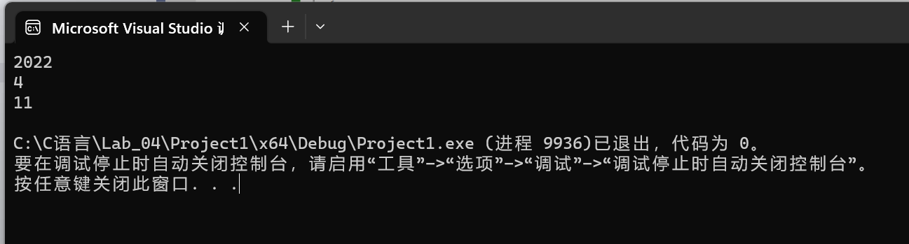
Discussion:
1．Most difficult parts
（What were the most difficult parts of your program to implement?）
How to get the corresponding number of the data.
2．Bugs and/or Errors
(List all the program bugs/errors you encountered and how you corrected them.)
Nope

